**Acetamenophen**

**WO 1997017947 A1**

**Formula:**

|  |  |  |
| --- | --- | --- |
| **N°** | **Constituants** | **Quantity (% w/w)** |
| 1 | Microcrystalline cellulose coprocessed 2% w/w colloidal silicon dioxide  (MMC coprocessed 2%w/w CSD) | 17.6% |
| 2 | Acetamenophen (APAP) | 80% |
| 3 | Colloidal silicon dioxide (CSD) | 0 .5% |
| 4 | Sodium starch glycolate (SSG) | 1 .5% |
| 5 | Sodium stearyl fumarate (SSF) | 0.4% |

|  |  |  |  |  |
| --- | --- | --- | --- | --- |
| **N°** | **Constituants** | **Quantity (% w/w)** | **Grade** | **Properties** |
| 1 | Acetamenophen | 80% | DC 90 USP | * Crystal form: Orthorhombic type II. * Granular form. * Density: from 1 .29 to 1.32 g/cm3. * Average particle size : 250-300 µm (cross sectional diameter). * Moisture content : 0.6 – 1.5 %. |
| 2 | Microcrystalline cellulose coprocessed 2% w/w colloidal silicon dioxide | 17.6% |  | * pH: neutral. * Average particle size: 40-60 µm. * Tapped density: from 0.35 g/ml to 0.55 g/ml. * Moisture content: from 3% to 5% by weight. |
| 3 | Colloidal silicon dioxide (CSD) | 0 .5% | Cab-O-Sil PTG | * Glidant. * Density (Bulk): 3lb/ft3. * Density (tapped): 50 g/l. * Specific surface area: 200 m2/g. * pH (4% aqueous slurry): 3.7-4.3. * Refractive index: 1.46. * %SiO2 > 99.8 * Average particle length: 0.2- 0.3 microns. * 44 microns mesh residue 0.02% max. |
| 4 | Sodium starch glycolate (SSG) | 1 .5% | EXPLOTAB | * Super disentegrant. * Ph: 5.5 – 7.5. * Density (Bulk): 0 .801 g/cm3. * Density (tapped): 0 .97 g/cm3. * Average particle size: 38µm and 42µm by microscopy and sieving respectively. |
| 5 | Sodium stearyl fumarate (SSF) | 0.4% | PRUVTM | * Lubricant. * pH : 8.3 for a 5% aqueous solution at 90°C. * Density (bulk): 0 .2 – 0.35 g/cm3. * Density (tapped): 0 .3 – 0.5 g/cm3. * Density (true): 1.107 g/cm3. * Specific surface area: 1.2 – 2 m²/g. * Moisture content: <5.0% |
|  | Microcrystalline cellulose |  | EMOCOCEL 90M | * Diluent/ Binder. * Density (bulk): 0.28 g/cm3. * Density (tapped):0.43 g/cm3. * Density (true): from 1.512 to 1.668 g/cm3. * Flowability: 1.41 g/s. * Nominal mean particle size: 91µm. * Average particle size by laser diffraction: 130 µm. * Moisture content ≤5.0%. |

**Process:**

|  |  |  |  |
| --- | --- | --- | --- |
| **Step** | **Description** | **Equipments** | **Parameters** |
| 1 | MCC-SiO2 product 2%w/w SiO2:   * Combination of 6.2 kg of microcrystalline cellulose with 5.2 kg of water in a mix tank to form a slurry containing about 15% solids. * The pH was adjusted to neutral with about 3 ml of ammonium hydroxide. * Mixing the slurry for about 15 minutes then, combined with 2% W/W colloidal silicon dioxide. * The slurry was spray dried. |  | Mixing time: 15 min. |
|  | Inlet temperature: 215°C.  Outlet temperature: 125°C.  Atomizer wheel speed: 22,300 rpm. |
| 2 | * Addition of the coprocessed MCC to the high shear granulator along with the acetaminophen, CDS and SSG. * Mixing the ingredients dry,high shear conditions. | C:\Users\fafa\Desktop\schémas procédé\high shear.png  High shear granulator | Mixing time: 3 min.  Impeller speed: 200 rpm.  Chopper speed: 1000 rpm. |
| 3 | * Addition of sodium stearyl fumarate and mixing was continued. | C:\Users\fafa\Desktop\schémas procédé\high shear.png  High shear granulator   * A V-blender can also be used. | Mixing time: 25 seconds.  Impeller speed: 200 rpm.  Chopper speed: 500 rpm. |
| 4 | Direct compression |  | Compression force: 25kN. |
| 5 | Coating (in option) using EUDRAGIT L100-500 and/or HPMC Opadry colorcon. |  | Temperature: 60 - 70°C.  Time: 3 – 4h. |

**Tablets caracterestics:**

|  |  |
| --- | --- |
| Acetamenophen | 75% by weight |
| Average tablet hardness | 6.5 Kp |
| Dissolution time  ( 900 ml phosphate buffer pH=5.8 USP23) | 30 min |

**Active substance properties:** (continuation)

1. FTIR:

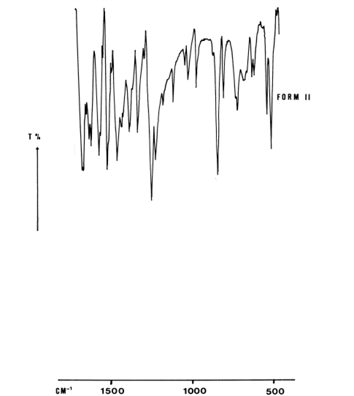



1. DSC:

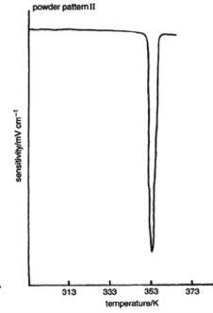

**DSC, thermogram of acetaminophen form 2**

1. XRD:

